Fading Effect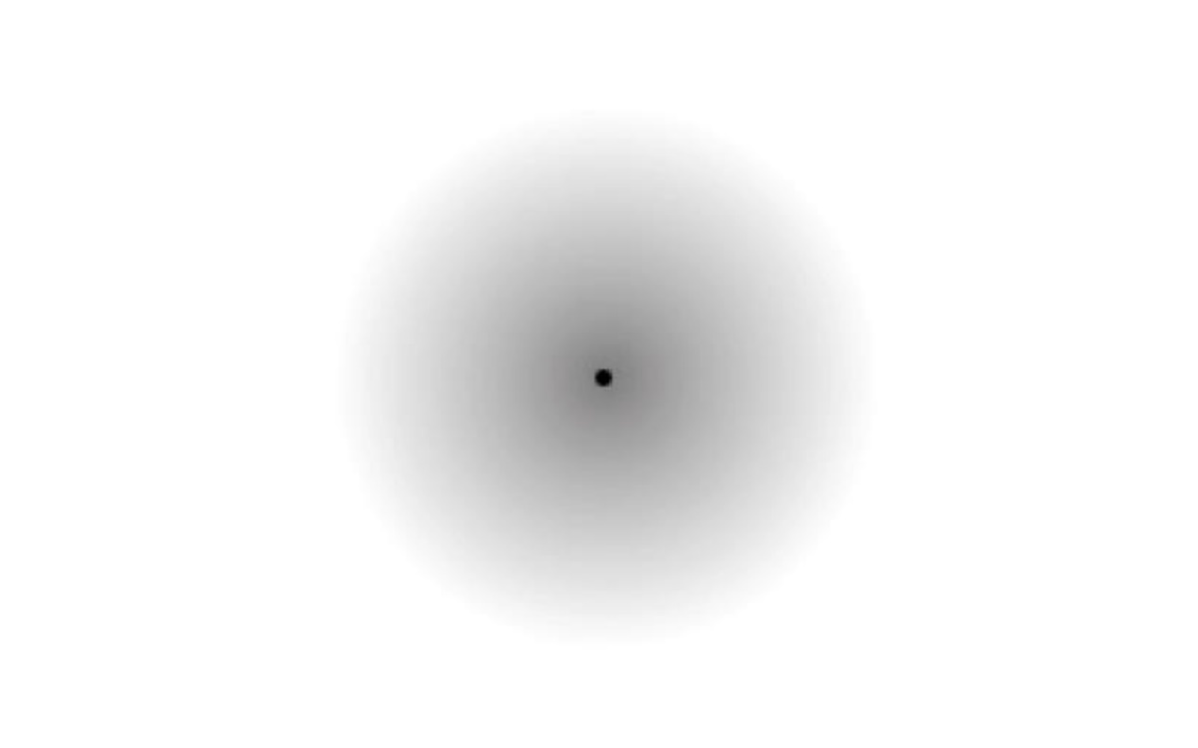
Stare at the little black dot in the middle of the grey patch until something happens to the grey patch.
- What happened to the grey patch?
- How long did this take?
- What is happening to the cells in your eye and/or brain when this occurs?
- Can you think of an example of a similar phenomenon in another sense modality? Be explicit about how you think your example is similar to this fading effect.
Thick and Thin Lines Effect
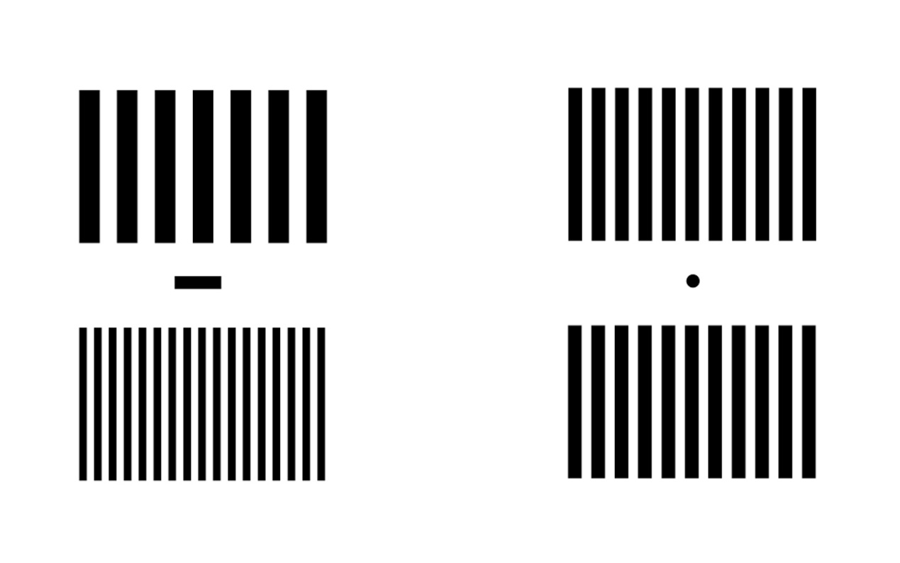
Note that we have an A stimulus and a B stimulus. First, look at the B stimulus on the right.
5. Are the two sets of lines above and below the black dot the same thickness?
Now, stare at the black bar in between the two sets of black and white lines in the A stimulus on the left for about 60 seconds. You might want to cover the B stimulus with a blank piece of paper while you do this. Now quickly move your gaze to the black dot in between the two sets of lines in the B stimulus.
6. What happened to the lines in the B stimulus?
Tilted Lines Effect
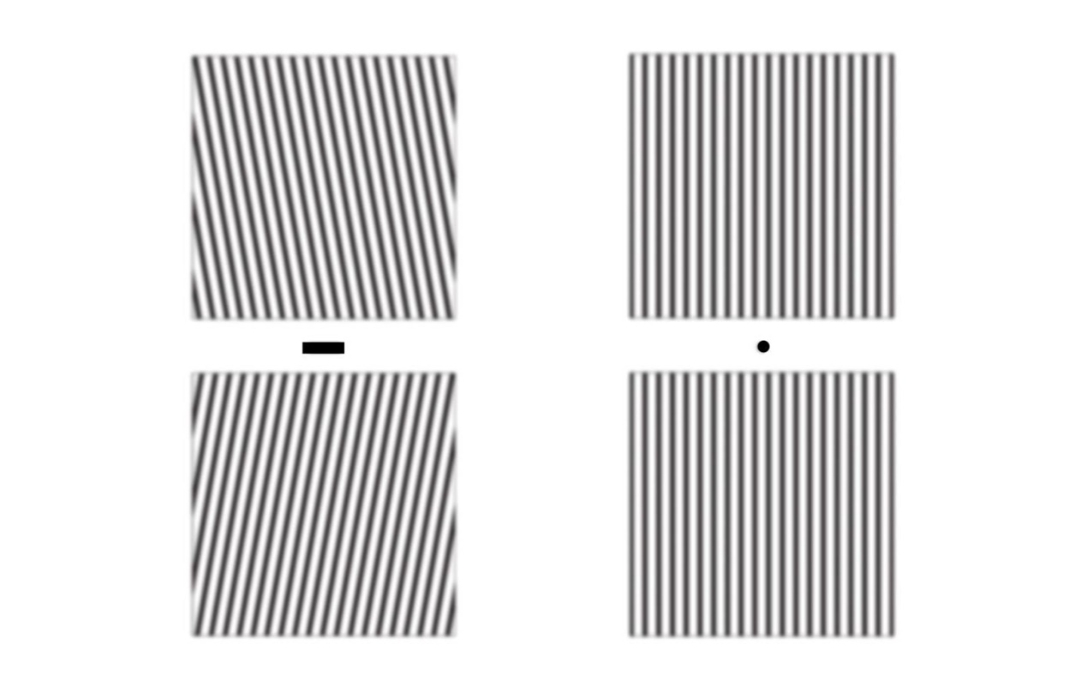
Note that again we have an A stimulus and a B stimulus. First, look at the B stimulus on the right.
7. Are the two sets of lines above and below the black dot vertical or tilted?
Now, stare at the black bar in between the two sets of black and white lines in the A stimulus on the left for about 60 seconds. You might want to cover the B stimulus with a blank piece of paper while you do this. Now quickly move your gaze to the black dot in between the two sets of lines in the B stimulus.
8. What happened to the lines in the B stimulus?
Coloured Castle Effect
First look at the B stimulus.
9. Is the B stimulus in colour, or black and white?
Now, stare at the black dot in the middle of the A stimulus for about 60 seconds. Now quickly move your gaze to the black dot on the B stimulus.
10. What happened to the B stimulus?
11. How long did the afterimage last? Can you do anything to make it disappear more quickly?

Integrative Questions
12. Is there any consistency in the relationship between the A stimulus and the B stimulus for the last three effects? If so, what is it?
13. What do these four effects have in common?
14. What might be happening to the cells in your eyes and brain during this phenomenon, as you sense the A (and B) stimuli?

